**Introduction**

The media in the United States has always been an important tool for politicians while campaigning and even more so for those seeking reelection. Politicians who are running for reelection find the media to be a useful tool because they have a stronger relationship with the media than challengers, which generates stronger name recognition amongst constituents. “They are better known because they spend a great deal of time, energy, and money trying to make themselves better known.”[1] Incumbents must now adapt to the evolving media system in America to secure their reelection by adopting social media (e.g. Facebook, Twitter, Instagram, etc.) into their campaign strategies. Why must they adapt to include this new form of media? Studies show that politicians who utilize social media acquire more votes than those who don’t use social media and challengers are shown in studies as using social media more frequently. Incumbents must add these new platforms to campaigning or challengers will potentially defeat them in elections by securing more votes through social media.

Studies have shown the importance of social media use in winning reelection, however, research on the effects of social media in relation to race are lacking. The goal of this study is to examine the effects of social media on the participation of African Americans in presidential elections. Social media is creating a new media system which is referred to as the hybrid media system and makes the presence of politicians online even more important. The growing importance of an Internet presence for politicians also comes with the benefits correlated with such a presence. One of the benefits that come from an online presence is the ability to decrease spending on advertising because of the resources found on social media platforms. Social media also creates the opportunities for Incumbent politicians to both combat selective exposure as well as establish more control over their message. Examining how these benefits can be related to race is a newly established connection because of President Obama and his candidacy.

**Research Questions**

1. Did President Obama generate an increase in the participation of African Americans in relation to monitoring presidential elections on social media?
2. Was the party identification of the African American respondent an influential factor in their participation?

**Literature Review**

Traditional media (Traditional media (e.g newspapers, radio, television, etc.) used to be one of the main sources of advertising in campaigns which benefited incumbents more than challengers because of the cost. Incumbents in the past were also granted advantages because of their position in office which allows them to send newsletters to constituents or make press releases. Social media combined with the increasing importance of the internet in America has eliminated those advantages previously experienced through traditional media. The increasing importance of the Internet in citizens' daily lives has generated an equal increase in its importance for campaigning.[2] The evolving media system in America has made the presence of politicians on the Internet necessary because of the way it allows them to reach constituents in a cost-effective manner. The ability for an incumbent to take advantage of both social media and traditional media places them in a better position because they get the benefits generated by both media systems. Incumbents don't have to rely on social media for their message to reach the traditional media outlets, because they already can spread their message with such outlets.

The hybrid media system in the United States also makes it necessary for politicians to increase their presence online. Media systems being connected to each other is what “hybrid media” defines and the flow of information across those connections. Therefore, taking advantage of one’s position as an incumbent and utilizing the relationship already established with the traditional media the next logical step is to move online. Studies show that incumbents have regularly adopted the Internet into their campaign strategies, but one cannot simply rely on their generic government website to win votes. “A study of the 2000 Senate races found that all but five of the 68 major party candidates, or 93%, and 60 of 103 third-party candidates, or 58%, had campaign Web sites.”[3] The data from this study allows the observation of how websites had become common among most candidates during the 2000 Senate races. Therefore, showing that the Internet was even important before it had become fundamental in people’s everyday lives. Web presence is essential in modern campaigns and as challengers are more likely to use the Internet since they don’t have easy access to traditional media platforms. Candidate’s web presence is no longer determined just by having a website but now includes other platforms of the Internet like social networking sites (e.g. social media). The use of social networking sites is important because being active on them increases the web presence of the candidate and certain sites require active participation to use them properly. Candidates can create a compounding effect on their web presence by adopting multiple social media platforms. Figure 1displays the importance of web presence for candidates in a Senate race. “The number of votes received increases by nearly 700,000 when moving from the lowest web presence to the highest.”[4] Level of web presence in large elections is essential because if the incumbent has a lower web presence than the challenger the election could be decided by the votes they get in proportion to their web presence.

**Social Media is Free Advertising**

The main thought on the mind of every politician while in office is securing their reelection and what they can do to achieve that goal. “Whether they are safe or marginal, cautious or audacious, congressmen must constantly engage in activities related to reelection.”[5] Social Media allows incumbents to engage in an activity that can benefit his reelection daily. The different platforms of social networking sites (Twitter, Facebook, and Instagram) all allow a politician to interact with constituents daily in different ways. All the varying ways that these platforms can be utilized are forms of advertising that don’t cost an incumbent any money. The current media system in America is one where being both on social media and on television can allow an incumbent to connect with their constituents on a larger scale. Candidates who have a presence on both forms of media benefits from the fact that the younger generations in America currently focus on more than one screen at a time. Positive predictors for having engaged with a presidential candidate through social networking sites in any form were the sociocognitive motivations for using a second screen.[6] Sociocognitive refers to how people process, store, and apply information about other people and social situations. The way platforms like Facebook and Twitter are set up is that when someone shares, likes, or retweets a post that information gets distributed to their friends or followers at no cost to the person who posted. Social media allows an incumbent to not only reach people who agree with their political views but also those from the other party who are friends with the person that shared the message of the candidate.

Advertising through social networking sites not only allows incumbents to save money on campaigning expenses. *Appendix 1* shows the increasing amount of spending on political ads for online/digital purposes and highlights the potential savings that social media could create for campaigns. Platforms like Instagram allow candidates to connect with the voters on a more personal level by sharing photos of their families, offering behind the scene looks, thank you messages, and pictures from rallies.[7] The personalization of politicians through social media is beneficial because it allows voters to feel a stronger connection to their candidate. Instagram can be used as a virtual billboard and like campaigning in the past where politicians would display themselves as family oriented through television ads including their families. Incumbents, unlike challengers, can take advantage of traditional media and still air those television ads; however, they don’t have to pay for as much airtime if they have enough followers on social media. Studies show that the shift to digital media is showing a steady decrease in the amount candidates are spending on traditional media advertisements. [8] The decrease in the amount of spending on traditional media, however, shows an increase in digital advertisement spending. Incumbents who want to campaign efficiently will adopt social media because it will allow them to decrease the amount of spending for both traditional and digital.

The number of followers a candidate has on social media is essential to increase the productivity of advertising on social networking sites because each platform doesn’t reach the same demographic. “Regarding demographics, Instagram users are more likely to be female, non-white, and between the ages of 18-29, with 28% of adult Internet users using the platform.”[9] The population of constituents for that one platform demonstrates the necessity for candidates to not only adopt a single platform. Facebook and Twitter also have different demographics of users that can be targeted through advertising on social media. “Facebook remains the most-used social networking platform, as two-thirds of online adults say that they are Facebook users. Women are more likely than men to be Facebook users, and Facebook use is especially common among younger adults.”[10] Growing technology and the increasing importance of the Internet in people’s everyday lives continues to shift the groups of people that use specific social networking sites. Incumbents who adopt multiple social networking sites will be able to reach the varying populations that frequent those sites and that will result in less spending on advertising that may only reach certain voters because of selective exposure.

**Combating Selective Exposure**

Incumbents benefit from the way that social media allows them to reach people who don’t have similar ideologies, because of the combination of selective exposure and the number of media choices available. Selective exposure refers to individuals’ tendency to favor information which reinforces their pre-existing views while avoiding contradictory information. The selective exposure of American citizens can be combatted with Facebook and Twitter by increasing the candidate’s number of followers. A larger population of followers on social networking platforms increases the potential range of the politician’s message because every extra follower has their own followers. Social networking sites create a sort of domino effect where once something is shared it has the potential to spread outwards and downwards through the list of followers. The domino effect is essential for incumbents because it allows them to increase their name recognition among voters. Voters are always changing with the addition of new voters each year; therefore, politicians must become better at advertising themselves to stay on the voters' minds.[11] Social media allows an incumbent to reach voters that may not follow them because of differing ideological beliefs, but who live in their district and potentially could vote for their reelection. The active use of social media not only allows them to reach wider audiences, but it increases their web presence which is essential in combatting selective exposure in high choice environments.

Web presence is fundamental in increasing the name recognition of candidates while minimizing the effect of selective exposure. “Recent research shows that 85% of Americans go online, and while they are there, 78% of them get their news online and 61% specifically look for news or information about politics.”[12] *Appendix 2* illustrates the selective exposure of people while looking at news information online. Conservatives and liberals are going to go from one source that aligns with their ideology to a similar one 96% of the time. Social media users utilize the platforms in a similar fashion by only following politicians that align with their ideological stance. Increasing the number of followers that an incumbent has on social networking sites will allow them to combat this selective exposure. Twitter creates a separate scenario that allows candidates to bypass selective exposure. People who use Twitter are more likely to be attentive to news and to politically participate online.[13] The participation is usually the discussion of politics on Twitter in the form of debating or expressing one’s own ideas in the comments on tweets. People debating with conflicting views benefit the incumbent because it brings voters who normally wouldn’t view their page or posts. Social networking sites also create the ability for candidates to spread their own message.

**Controlling the Message**

Politicians not only have to compete with conflicting ideologies that limit the number of constituents that access their information or see their message, but also must compete with the levels of entertainment access that Americans have at their disposal. [14] Mobile devices have increased the entertainment choices readily available to constituents that make having social media networking sites necessary to get their message across. Studies show that only 40 percent of Americans post political content, however, 80 percent come across such content on social networking sites.[15] The lack of people posting political messages on social networking sites doesn’t affect the overall number of people who come across the content as shown in the study. Traditional media creates more restrictions on reaching people in a high choice environment because if people don’t want to view the information they can change channels or stations on the radio. Political knowledge has been observed as decreasing because viewers can choose entertainment over political news easier with the new media system.[16] Incumbents, therefore, should feel the need to adopt social networking sites to reach the group of people who prefer entertainment. Those with a preference for entertainment can’t avoid political information as easily on social media. The study shows that the percentage of Americans who view the political information is twice the size of those posting, therefore, social media allows political content or messages to bypass the content preferences of viewers. Candidates being able to bypass the content preference through social media make the messages they distribute through such networks crucial in educating voters.

Incumbents who create messages and distribute them through social media have the ability to reach a wide audience. The message that one chooses to spread is also important to consider when campaigning through social networking sites. Incumbents who adopt social media are able to have more control over their message as it is spread to constituents without having to pay advertisement costs to control that message. Social media allows for politicians to have more control over their message without it being filtered by media outlets.[17] The ability for a candidate to bypass the filtering mechanisms found in traditional media is another reason why incumbents should adopt social media. American citizens have started to doubt the information they come across on traditional media outlets, however, the public treats social media differently. Roughly 50% of the public who follow candidates on social networking sites believe the information is more reliable.[18] Incumbents who want to secure their reelection have to use social media because as noted above if they don’t control the message it leaves that open for challengers. Research shows that challengers are already more likely to use social media, so if they are the one controlling what is heard about the incumbent it minimizes the effects of campaign spending. The way it affects the efficiency of campaign spending is by countering the information candidates distribute through advertisements on traditional media outlets. Information found on social networking sites being believed by roughly 50% of the public means that if challengers have a stronger presence on social media they can control the information available.

**The Obama Effect**

Race has always played a major role in southern politics and is something that the original party to dominate in the south based a lot of its ideology. The Democratic Party that originally controlled the south was one with an ideology that favored Jim Crow laws. Conservatism under the Democratic Party was something easily associated with racism and that could play a role in why a large majority of black southerners don’t want to associate themselves with the conservative ideology. Race no longer plays the same role in southern politics today, however, because Jim Crow laws are no longer a factor. The role race now plays is by dividing the population of the southern voters into different groups of ideology. White southern voters tend to be conservative and have regularly identified themselves as Republican and helped the party maintain control of the south until now. Black southern voters tend to be liberal or populist but haven’t regularly identified themselves as Democratic. Fowler discusses how there is a possibility that the African American voters have a reluctance in adopting ideological labels because of the association between racism and the Democratic Party of the past. Maxwell and Fowler both discuss the role that President Obama has played in the decreasing single-party control of the south. The “Obama effect” as Fowler refers to it is giving the Democratic party a revival. President Obama didn’t attempt to abuse race loyalty as a means of motivating voters, however, his campaign did result in a large increase in voter turnout and voter registration within the African American community. The single-party domination in the south is threatened by this because it gives African American voters a reason to self-identify as liberal and is increasing voter turnout among a population that didn’t regularly vote in the conservative controlled south.[19]

The study I am proposing will look at the "Obama Effect" in relation to social media use by African Americans. Data from this study will help as the study of social media use for African Americans will help increase the field of digital politics. The data will do so by allowing a broader understanding of the effects generated by a minority candidate, such as increasing turnout. I will do a better job of addressing the impact President Obama had on African Americans by looking at their party identifications and the role they played in participation between 2012 and 2016. The observation of the change that takes place after President Obama leaves office will also allow for a clearer understanding of the overall impact his candidacy had on African Americans. Incumbent politicians whether they are African American or not can also capitalize on the results of this study by embracing social media in a similar fashion and generating an increase in voter turnout. The increase in voter turnout is among a population that is not generally active and will benefit those seeking reelection.

**Hypotheses**

I expect this paper to yield two separate hypotheses in relation to President Obama's impact on African American participation. The participation observed between the two data sets will allow for a clear understanding of Obama's impact because the 2016 election did not feature a minority or African American candidate.

First, I posit that Obama's presence as a candidate in the 2012 election will demonstrate an impact by showing a larger population of African American participation on social media.

**H1.** If President Obama's candidacy generated an increase in the number of African Americans using social media to monitor presidential elections than there should be a decrease between 2012 and 2016.

Second, I posit that Obama's presence as a candidate will also generate a stronger Democrat identification for African Americans regarding social media use for the 2012 election. There should be a positive correlation between social media use and African Americans who identify as a Democrat.

**H2**. If President Obama's candidacy generated an increase in the level of Democrat identification for African Americans, there should be a stronger correlation in 2012.

**Conceptualization**

For this paper, there is a single dependent variable and multiple independent variables. The dependent variable in both hypotheses is the level of social media use to monitor the presidential election. African American and not African American are the independent variables in the first hypothesis. President Obama's presence as a candidate in the 2012 election should show a higher level of participation for African Americans than the 2016 election. African American party identification is the independent variable for the second hypothesis. The lack of Obama's presence in 2016 should show a decrease in the strength of Democrat identification for African Americans in relation to social media use. The unit of analysis for this study will be the levels of social media use from both 2012 and 2016.

The levels of social media use were conceptualized using the data found from the American National Election Study of 2012 and 2016. R Studio was used to test the statistical significance of relations between the level of social media use in relation to the race of the respondent as well as the party identification of respondents. The level of social media use is measured by the number of days the respondent used social media to monitor the presidential election of that year. Party identification was measured in a similar fashion by having the respondents self-identify their level of party identification in relation to Strong Democrat and Strong Republican.

**Methodology**

This project measures the changes in social media use with the relationship between African Americans and the presidency of Barak Obama. The samples for this study were pulled from two surveys conducted by the American National Election Studies (ANES) which has its data readily available online. ANES Time Series studies have been conducted since 1948, typically through in-person interviewing, during years of biennial national elections. Topics cover voting behavior and the elections, together with questions on public opinion and attitudes of the electorate. In all Time Series studies, an interview is completed just after the election (the Post-election or "Post" interview); during years of Presidential elections an interview is also completed just before the election (the Pre-election or "Pre" interview). The Time Series studies allow for an accurate study of the changes that take place over time between elections.

There are several dummy variables as well as control variables that were coded to allow for more generalizable results from this study. One of the tests ran required a dummy variable to be created for social media use that separated it into three categories: low use, medium use, and high use. Social media use was on a scale from 0 days a week to 7 days a week (low use = 0-2 days, medium use = 3-5 days, high use = 6-7 days). The dummy variables for testing the main dependent variables are for the race of the respondent (0 = African Americans, 1 = not African American) and the party identification (PID) of the respondent (0 = Strong Democrat, 1 = Strong Republican). A separate dummy variable was also created to represent African American party identification (African American dummy*PID estimate). Basic control dummy variables were also created for gender (male = 0, female = 1) and age, however, the age variables were different in 2012 and 2016. ANES 2012 had the age variables grouped (17-20=1, 21-24=2, 25-29=3, 30-34=4, 35-39=5, 40-44=6, 45-49=7, 50-54=8, 55-59=9, 60-64=10, 65-69=11, 70-74=12, 75 and up=13) the grouped variables were rescaled from 0-1 ((age-1)/12). ANES 2016 had age ranging from (18-90) age was rescaled similarly to 2012 ((age-1)/89). The final dummy variable was socioeconomic status (SES) the variable looks at a combination of education and income that is calculated using R studio.

Histograms were utilized to allow for an overall understanding of the change that took place in social media use levels between the two datasets. The tests will be conducted to examine the relationship between the different independent variables and the dependent variable. Contingency tables will be generated to examine the relationship between the collapsed variable for social media use and the dummy variable for race to examine the change that took place between 2012 and 2016. Multivariate regression models will be ran for each dataset and compared to examine how the variables changed in significance over time. Results will be declared statistically significant if they generate a p-value = .05 or less. The results will be used to determine whether hypothesis 1 or hypothesis 2 are proven correct or disproved.

**Results**

This paper sought to examine the impact that President Obama's candidacy had on African American voters and their use of social media to monitor elections. Understanding how the use of social media has increased in importance can be understood by observing the change in social media use between the two datasets.

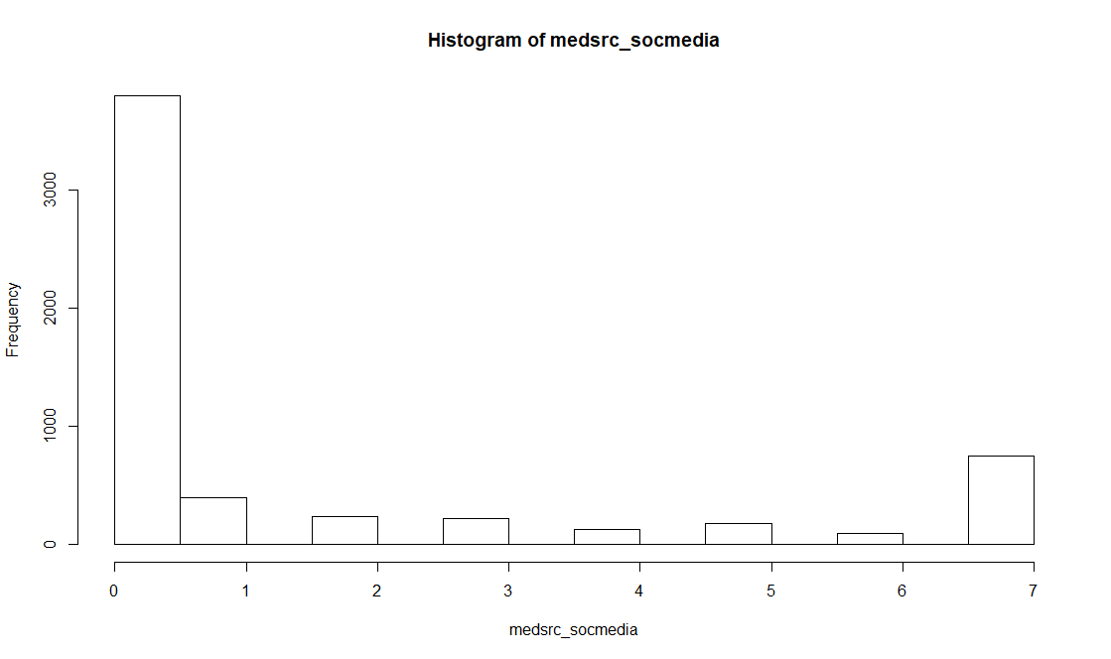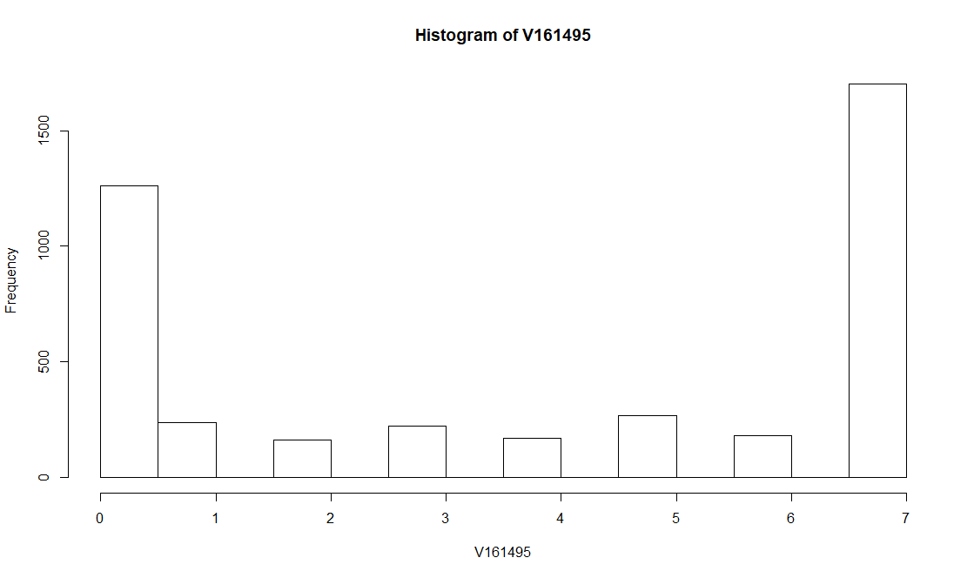

Figure 1.1 Social media use 2012 Figure 1.2 Social media use 2016

The histograms show the drastic increase in social media use that took place between the four years the surveys were conducted. ANES 2012 showed a larger population of respondents who said they didn’t use social media at all to monitor elections than all of the other options provided to respondents. The study from 2016 showed the exact opposite and the means from the two allow for a better understanding of how the average use increased. The mean during the 2012 survey was 1.49 days a week and in 2016 it was 3.87 days a week. Social media use experienced more than a 200% increase between the four years.

*Hypothesis One*

|  |  |  |  |
| --- | --- | --- | --- |
| **Table 1: Contingency Table for Race and Social Media Use in 2012 and 2016** | | | |
| Social media 2012 | Not African American | African American | Totals |
| Low use | 3686 (0.774) | 721 (0.735) | 4407 |
| Medium use | 394 (0.083) | 112 (0.114) | 506 |
| High use | 685 (0.144) | 148 (0.151) | 833 |
| Totals | 4765 (0.829) | 981 (0.171) | 5746 |
| Chi2 = 82.56724 d.f. = 2 p = 1.176931e-18 | | | |
| Social media 2016 |  |  |  |
| Low use | 1470 (0.389) | 175 (0.412) | 1645 |
| Medium Use | 570 (0.151) | 85 (0.181) | 655 |
| High Use | 1737 (0.460) | 134 (0.406) | 1871 |
| Totals | 3777 (0.906) | 394 (0.094) | 4171 |
| Chi2 = 23.69253 d.f. = 2 p = 7.165262e-06 | | | |

This Hypothesis sought to determine if President Obama’s candidacy in the 2012 presidential election created an increase in the levels of social media use by African Americans to monitor the election. The contingency table in *Table 1* was generated through cross tables that were ran for both ANES 2012 and 2016. Cross tables are important for generating the percentages for levels of social media use for African Americans and not African Americans. The overall total percentage of African Americans who used social media to monitor the presidential election experienced a drop from 17.1% in 2012 to 9.5% in 2016. P-values as discussed previously allow for an understanding of the statistical significance of the tests ran and both 2012 and 2016 showed statistical significance. The tests prove that race had significance in both data sets, however, statistical significance was stronger in 2012 with a p-value of p = 1.176931e-18. Hypothesis One is proven to be correct with this test as it shows both a decrease in the total percentage of African Americans who used social media to monitor the elections after President Obama’s candidacy.

*Hypothesis Two*

|  |  |  |  |  |
| --- | --- | --- | --- | --- |
| **Table 2: Multiple Regression Model 2012** | | | | |
| Variable | Estimate | Standard error | t-value | p-value |
| Intercept | 1.858 | 0.232 | 7.994 | 1.58e-15 *** |
| SES | -0.282 | 0.136 | -2.076 | 0.0379* |
| Age | -1.873 | 0.117 | -15.96 | < 2e-16*** |
| PID | -0.297 | 0.298 | -0.997 | 0.3189 |
| Race | 0.225 | 0.105 | 2.134 | 0.0329* |
| Gender | 0.341 | 0.065 | 5.171 | 2.41e-07*** |
| African American PID | 0.112 | 0.21 | 0.533 | 0.5940 |

Table 2 Multiple Regression Model for ANES 2012; *p ≤ .05. **p ≤ .01. ***p ≤ .001.

The multiple regression models with the dependent variable being social media use and the independent variables being: socioeconomic status, age, party identification on the 7-point scale, race which was coded to African American and ‘not African American’, the gender of the respondent, and the African American PID. The PID variable listed in *Table 2* is a variable that must be subtracted from the African American PID to allow for an analysis of the overall effects of PID. Further steps must be taken to analyze the results of the test because of the separate dummy variable. Therefore, the overall estimate for African Americans in 2012 is .409 (.112-(-.297)). The coding for the regression model is set up to where the higher value for party identification is Strong Republican (1) and the lower is Strong Democrat (0). Interpreting the results from the regression model shows that the relationship between PID and social media use is stronger in relation to African American party identification. The stronger of a Democrat the non-African American is the more (-0.297) likely they are to use social media. African Americans who identify less with the Democratic Party are more likely (.409) to use social media

|  |  |  |  |  |
| --- | --- | --- | --- | --- |
| **Table 3: Multiple Regression Model 2016** | | | | |
| Variable | Estimate | Standard error | t-value | p-value |
| Intercept | 4.916 | 0.229 | 21.44 | < 2e-16 *** |
| SES | 0.304 | 0.093 | 3.261 | 0.0011** |
| Age | -5.703 | 0.227 | -25.08 | < 2e-16*** |
| PID | 1.8 | 0.676 | 2.666 | 0.0077** |
| Race | -0.407 | 0.197 | -2.071 | 0.0385* |
| Gender | 1.108 | 0.09 | 12.31 | < 2e-16*** |
| African American PID | -1.515 | 0.635 | -2.384 | 0.0172* |

Table 3 Multiple Regression Model for ANES 2016; *p ≤ .05. **p ≤ .01. ***p ≤ .001.

Analyzing the multiple regression model of ANES 2016 was conducted using the same variables as the 2012 test. The African American PID variable in *Table 3* must be analyzed the same way as the variable from the previous table. African American PID for 2016 ends up being -3.315 ((-1.515)-1.8). The effect of PID for non-African Americans shows that the more a respondent identifies with the Republican party the more they use social media (1.8) to monitor presidential elections. However, the overall effect for African Americans shows that the more they identify with the Democratic Party the more likely they are to use social media. Hypothesis Two is disproven because the correlation between social media use and African Americans who identify as Democrats is stronger in 2016 than 2012. The hypothesis is also negated because the relationship between party identification and African American use of social media is stronger for the Republican Party.

**Weaknesses**

The main weakness of this study is the period of the data sets used for determining the results. President Obama was a candidate during more than one of the ANES time series surveys conducted. The study could be strengthened if the test were performed over the span of 2008-2016 to observe the effect he had over a larger span of time. Studying the party identification levels of African Americans can be conducted going even further back to 2004, however, social media being a new media system makes it difficult to observe using studies conducted before 2012. The study can only be re-conducted in the future when another candidate appears who will create a racial activation of citizens who generally have low signs of political participation. Researchers could also reconduct the study going further back and looking at traditional forms of media instead of social media to observe the changes after President Obama’s candidacy.

**Conclusions**

The purpose of this study was to examine the importance of social media use in monitoring presidential elections and the effect President Obama had on it for African Americans. By observing the changes that took place between the ANES 2012 times series study and the ANES 2016 study. The study allows for the observation of the growing importance of social media and the Internet as it became more important over the span of the study. Looking at the 2012 and 2016 time series study also allows the observation of the impact Obama’s candidacy had on African American respondents.

The first hypothesis was proven to be correct, which is to say that President Obama’s candidacy caused an increase in the political participation of African Americans on social media. Comparing the levels of social media use by African Americans and non-African Americans shows a drastic difference in the level of social media use to observe the election in 2012 and 2016. The percentage of African Americans dropped from 17.1% in 2012 to 9.5% in 2016. Looking at the percentage of respondents does show a positive correlation between Obama’s candidacy and social media use, however, even in 2016 low use of social media remains the norm for African Americans.

For the second hypothesis, the data did not align with the effect that was expected of President Obama’s candidacy. The comparison of the multiple regression models showed that there was less of a correlation with the Democrat Party than anticipated. The effect of PID for non-African Americans in 2016 shows that the more a respondent identifies with the Republican Party the more they use social media to monitor presidential elections. The effect for African American respondents showed that the more they identified with the Democratic Party the more likely they were to use social media. Hypothesis Two is disproven because the correlation between social media use and African Americans who identify as Democrats is stronger in 2016 than 2012. The hypothesis is also negated because the relationship between party identification and African American use of social media is stronger for the Republican Party. The research could be further conducted by looking at other minorities besides just African Americans to look at the impact Obama had on participation. More theory building could also be conducted to examine African Americans use of social networking sites for political participation.

Appendix

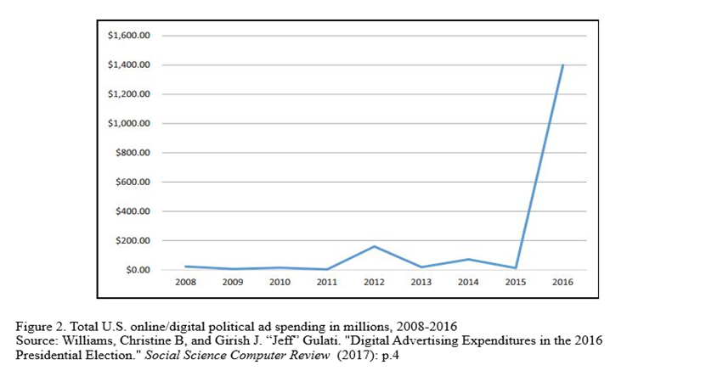

Appendix 1

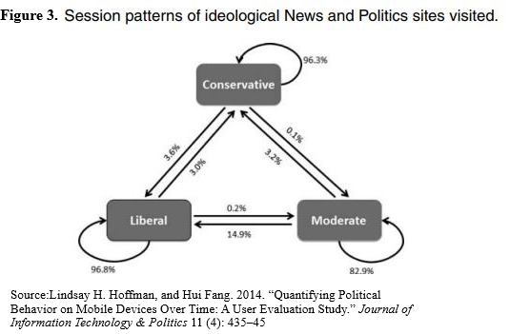

Appendix 2

Works Cited

Boulianne S. "Campaigns and Conflict on Social Media: A Literature Snapshot." *Online Information Review* 40, no. 5 (2016): 566-79

Duggan, Maeve, and Joanna Brenner. *The demographics of social media users, 2012*. Vol. 14. Washington, DC: Pew Research Center's Internet & American Life Project, 2013.

Fowler , Matthew. “ Race Still Matters: Political Ideology and the South .” *American Political Science Association*, 2016, pp. 215–220.

Gainous, Jason, and Kevin M Wagner. *Tweeting to Power : The Social Media Revolution in American Politics*. Oxford Studies in Digital Politics. New York: Oxford University Press, 2014.

Herrnson, Paul, Atiya Stokes-Brown, and Matthew Hindman. "Campaign Politics and the Digital Divide." *Political Research Quarterly* 60, no. 1 (2007): 31-42

Latimer, Christopher P. "Utilizing the Internet As a Campaign Tool: The Relationship between Incumbency, Political Party Affiliation, Election Outcomes, and the Quality of Campaign Web Sites in the United States." *Journal of Information Technology & Politics* 4, no. 3 (2008): 81-95

Lindsay H. Hoffman, and Hui Fang. 2014. “Quantifying Political Behavior on Mobile Devices Over Time: A User Evaluation Study.” *Journal of Information Technology & Politics* 11 (4): 435–45

Mayhew, David R. “From Congress: The Electoral Connection.” In *Readings in American Politics: Analysis and Perspectives.* 1974. p. 155-167

Maxwell, Angie. “ A Tale of Two Tea Parties? Southern Distinctiveness and Tea Party Membership.” *American Political Science Association*, 2016, pp. 210–214.

Muñoz, Caroline Lego, and Terri L Towner. "The Image Is the Message: Instagram Marketing and the 2016 Presidential Primary Season." *Journal of Political Marketing* 16, no. 3/4 (2017): 290-318

Nee, Rebecca Coates. "Social TV and the 2012 Election." *Electronic News* 7, no. 4 (2013): 171-188

Prior, Markus. “News vs. Entertainment: How Increasing Media Choice Widens Gaps in Political Knowledge and Turnout.” In *Controversies in Voting Behavior.* 2005. p.577-592

Wagner, Kevin M, and Jason Gainous. "Electronic Grassroots: Does Online Campaigning Work?" *The Journal of Legislative Studies* 15, no. 4 (2009): 502-20

Williams, Christine B, and Girish J. “Jeff” Gulati. "Digital Advertising Expenditures in the 2016 Presidential Election." *Social Science Computer Review* 089443931772675 (2017)

1. Mayhew, David R. “From Congress: The Electoral Connection.” In *Readings in American Politics: Analysis and Perspectives.* 1974. p. 160
2. Herrnson, Paul, Atiya Stokes-Brown, and Matthew Hindman. "Campaign Politics and the Digital Divide." *Political Research Quarterly* 60, no. 1 (2007): 31
3. Latimer, Christopher P. "Utilizing the Internet As a Campaign Tool: The Relationship between Incumbency, Political Party Affiliation, Election Outcomes, and the Quality of Campaign Web Sites in the United States." *Journal of Information Technology & Politics* 4, no. 3 (2008): 81-95
4. Wagner, Kevin M, and Jason Gainous. "Electronic Grassroots: Does Online Campaigning Work?" *The Journal of Legislative Studies* 15, no. 4 (2009): 502-20
5. Mayhew, David R. “From Congress: The Electoral Connection.” In *Readings in American Politics: Analysis and Perspectives.* 1974. p. 160
6. Nee, Rebecca Coates. "Social TV and the 2012 Election." *Electronic News* 7, no. 4 (2013): 182
7. Muñoz, Caroline Lego, and Terri L Towner. "The Image Is the Message: Instagram Marketing and the 2016 Presidential Primary Season." *Journal of Political Marketing* 16, no. 3/4 (2017): p.2
8. Williams, Christine B, and Girish J. “Jeff” Gulati. "Digital Advertising Expenditures in the 2016 Presidential Election." *Social Science Computer Review* 089443931772675 (2017)
9. Ibid., p.1
10. Duggan, Maeve, and Joanna Brenner. *The demographics of social media users, 2012*. Vol. 14. Washington, DC: Pew Research Center's Internet & American Life Project, 2013.
11. Mayhew, David R. “From Congress: The Electoral Connection.” In *Readings in American Politics: Analysis and Perspectives.* 1974. p. 161
12. Lindsay H. Hoffman, and Hui Fang. 2014. “Quantifying Political Behavior on Mobile Devices Over Time: A User Evaluation Study.” *Journal of Information Technology & Politics* 11 (4): 435–45
13. Gainous, Jason, and Kevin M Wagner. *Tweeting to Power : The Social Media Revolution in American Politics*. Oxford Studies in Digital Politics. New York: Oxford University Press, 2014.
14. Prior, Markus. “News vs. Entertainment: How Increasing Media Choice Widens Gaps in Political Knowledge and Turnout.” In *Controversies in Voting Behavior.* 2005. p.577-592
15. Boulianne S. "Campaigns and Conflict on Social Media: A Literature Snapshot." *Online Information Review* 40, no. 5 (2016): 566-79
16. Prior, Markus. “News vs. Entertainment: How Increasing Media Choice Widens Gaps in Political Knowledge and Turnout.” In *Controversies in Voting Behavior.* 2005. p.577-592
17. Gainous, Jason, and Kevin M Wagner. *Tweeting to Power : The Social Media Revolution in American Politics*. Oxford Studies in Digital Politics. New York: Oxford University Press, 2014.
18. Ibid
19. Fowler , Matthew. “ Race Still Matters: Political Ideology and the South .” *American Political Science Association*, 2016, pp. 215–220. Maxwell, Angie. “ A Tale of Two Tea Parties? Southern Distinctiveness and Tea Party Membership.” *American Political Science Association*, 2016, pp. 210–214.